***Take Home Assessment:***

As part of this assessment, you will be required to design the attached screenshot using HTML, CSS and Javascript. No Angular or react native or Vue.

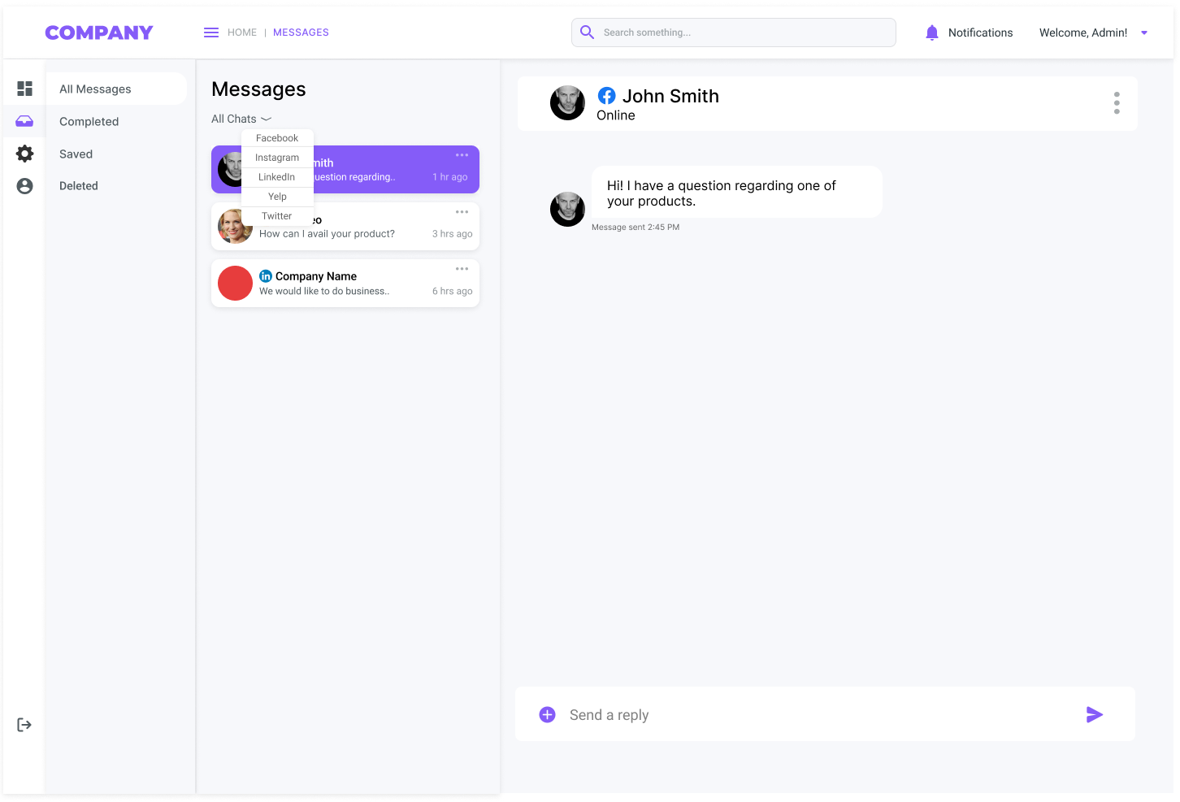

**Instructions:**

1. For icons in the screenshot, use any icon image you like. IT need not be exactly like the one in the above image.
2. You just need to implement the tab - “All Messages”. All other tabs are just the placeholders.
3. On the bottom left of the image -> It’s the logout button. Add a hover to indicate that it’s a logout icon.
4. Add 5 chats under -> “Messages” -> “All chats”. Each chat should be a clickable component. On click, display the chat history in the right big box (1-2 chat messages per thread).
5. No need to implement the filter under “All Chats” or Send a reply (bottom right). These are all placeholders. No event is triggered on the clicks.

**Please submit the following:**

1. HTML file, CSS and Javascript file

2. Screenshot of your work

3. instructions on how to run it locally. Example-> If you got an index.html file, then just say -> Open index.html in your web browser.

4. Send above to team@bling.cloud